Task 7: Identify and Remove Suspicious Browser Extensions

This report documents the process of identifying and removing suspicious browser extensions using Google Chrome. Browser extensions can pose serious security risks if they have unnecessary permissions or come from untrusted sources. Following steps ensure a safer browsing environment.

## Step 1: Open Extension Manager

In this step, we navigate to Chrome's Extension Manager using the URL 'chrome://extensions/'. This allows us to view all currently installed extensions in the browser.

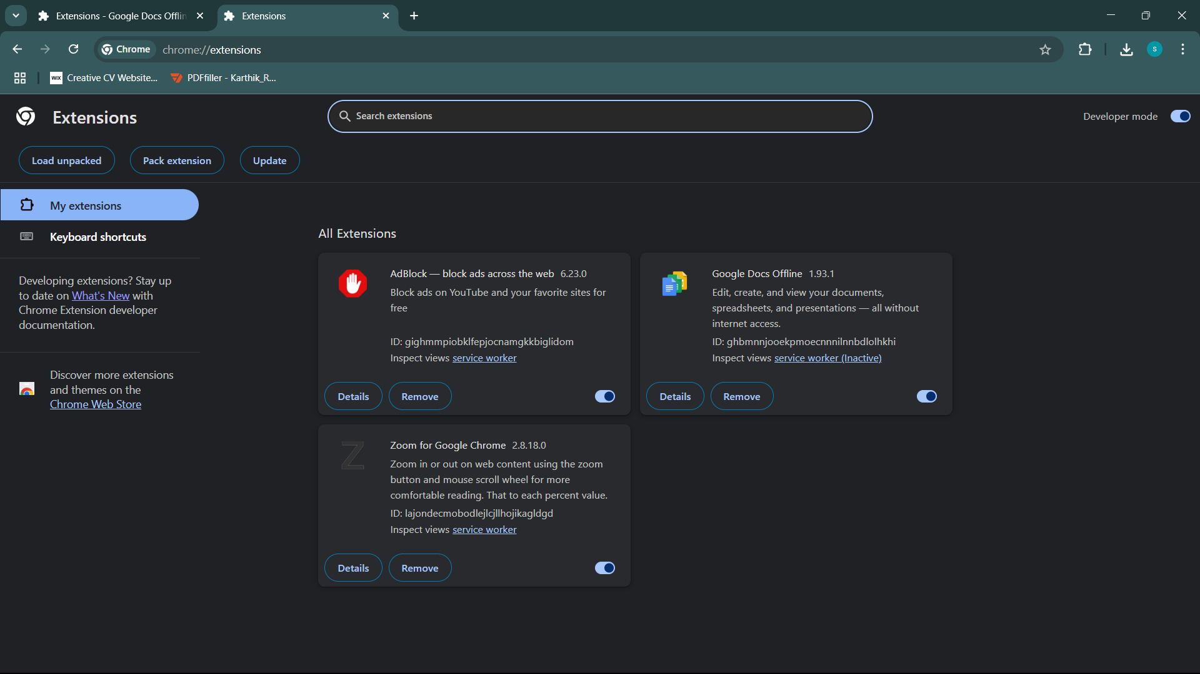

## Step 2: Review Installed Extensions

We carefully examine each installed extension. Suspicious signs include unknown developers, no ratings, and names that don't clearly explain functionality.

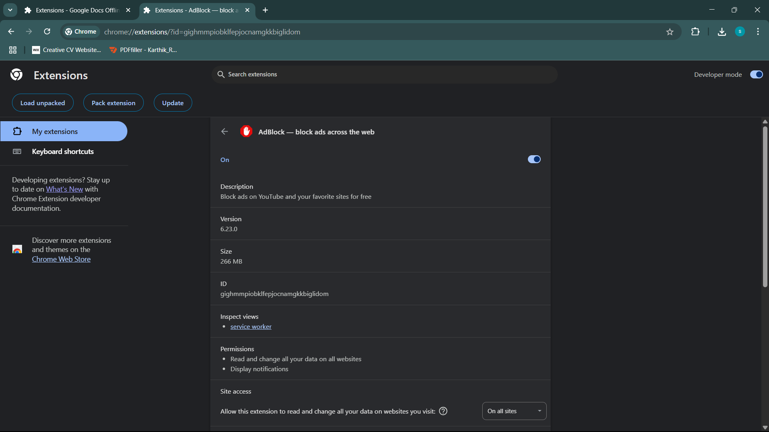

## Step 3: Check Extension Permissions

Clicking 'Details' under each extension shows the permissions it requires. High-risk extensions often ask for 'Read and change all your data on all websites'.

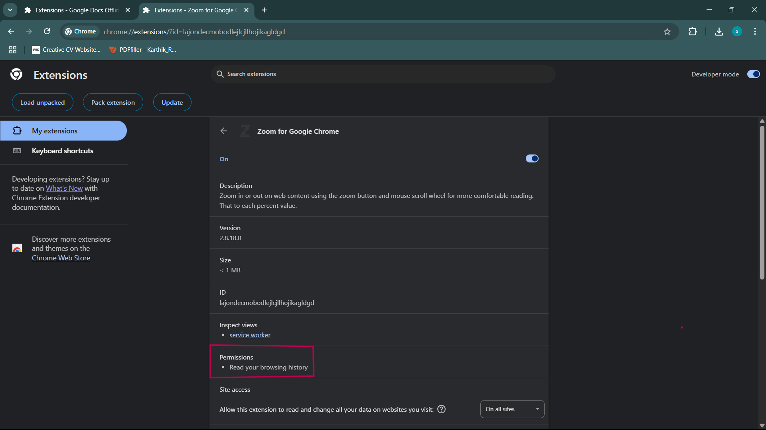

## Step 4: Identify Suspicious Extension (Before Removal)

Here we identify a suspicious extension that has broad permissions and unclear functionality. It's crucial to remove such extensions to prevent potential data leaks.

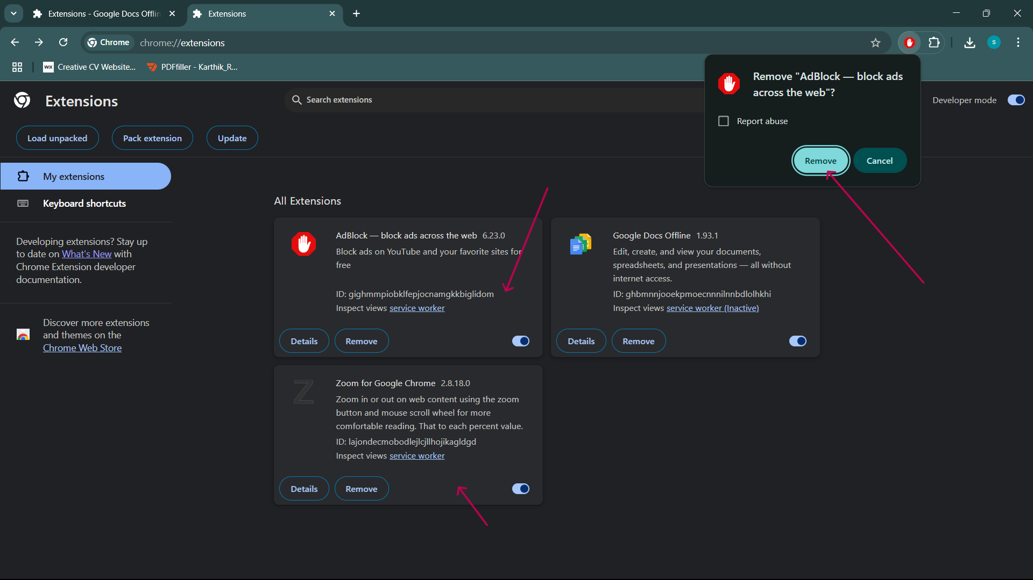

## Step 5: After Removal of Suspicious Extension

After clicking 'Remove', the suspicious extension is deleted from Chrome. This improves browser security and performance.

